PHASE 2: Producer Development

Step 2.1: Producer Configuration
- Create: D:\kafka-project\producers\config.py
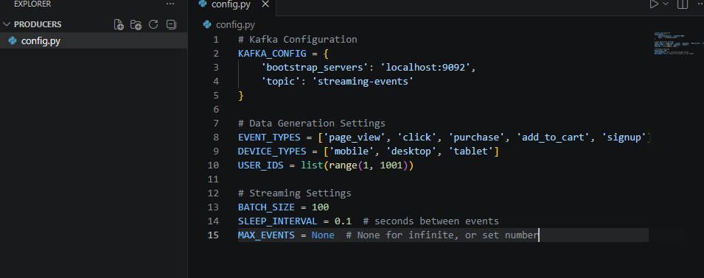

Step 2.2: Data Generator
- Create: D:\kafka-project\producers\data_generator.py
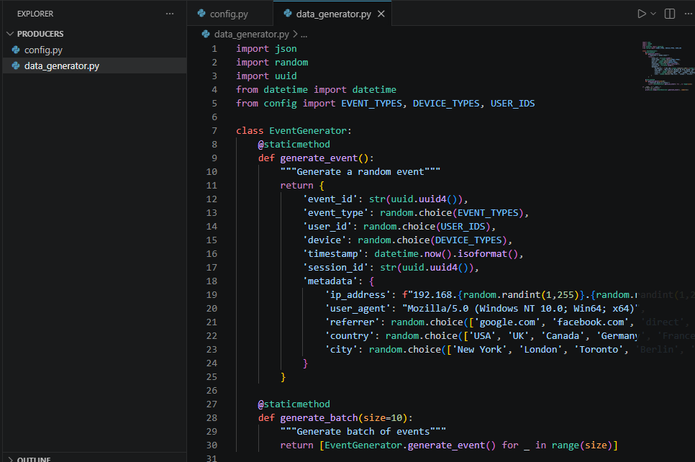

Step 2.3: Kafka Producer
- Create: D:\kafka-project\producers\producer.py
